SOUTHSIDE MISSIONS

MISSIONARY OVERVIEW
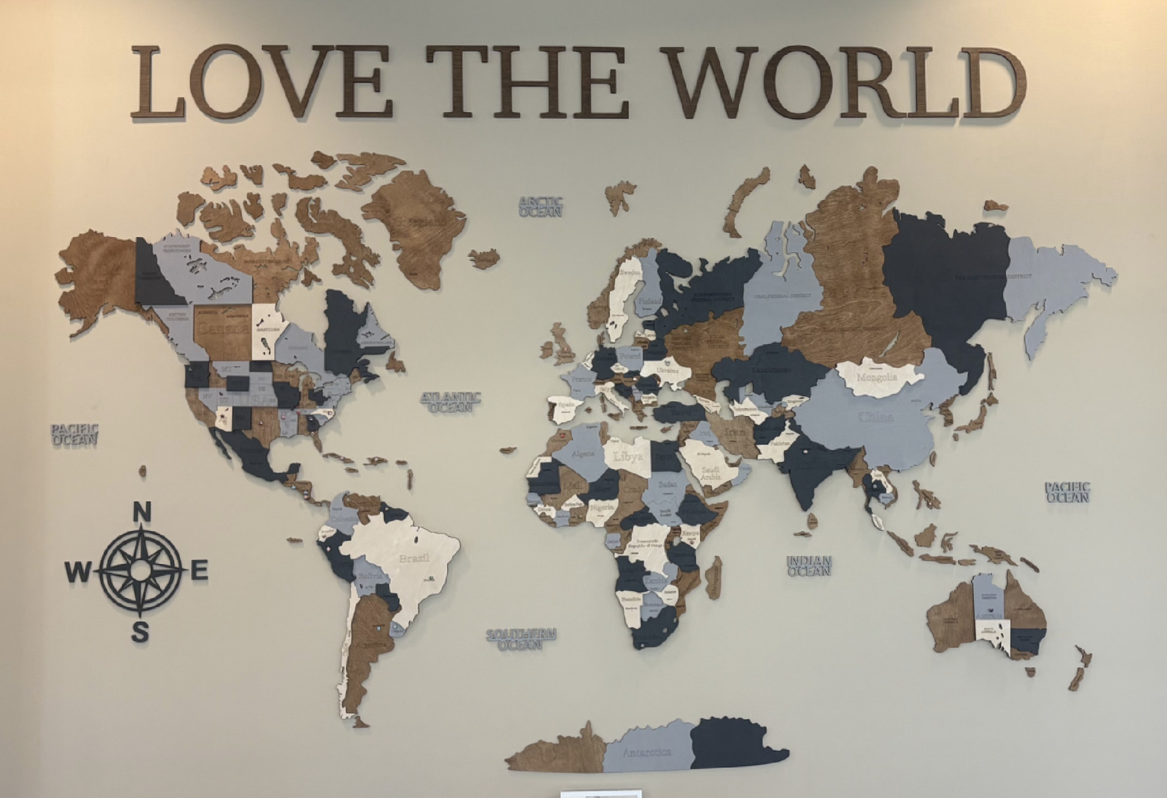
Take and read about Southside’s 48 missionary
partners and their extensive ministry work. Learn
more about how we Love the World, and be encouraged to pray for them by name!

For the Lord gave us this command when he said, "I have made you a light to the Gentiles, to bring
salvation to the farthest corners of the earth." Acts 13:47

Europe

Anonymous for Safety*
Supported by Southside since 2002
Missionaries who serve in Moldova with the ABWE organization. They are involved in church planting in and around Moldova, where they partner with many plants for strategy and outreach. They also have a crucial ministry for Ukrainian refugees. Opportunities for evangelizing are always present with the influx of refugees, and God has used them greatly for the salvation of His people.

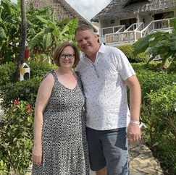
Marc & Charin Patton
•
Supported by Southside since 2013
Since 1993, Marc and Charin Patton have been church planting in Hungary, where there are only 2-3% evangelical Christians. From 1995
to 2025, the Pattons have planted five (soon to be six) churches all throughout Hungary. Year round, their ministry is with family camps, mission trips, refugee outreach, church planting conferences, and equipping others to steward the churches once they move to a new church plant. Their newest project and mission is a church plant on the northwest side of Budapest in Obuda. This is the oldest part of Budapest where 125,000 people live and it is the most unchurched area of Budapest with only 4 evangelical churches. Please be praying for the Patton’s ministry to thrive, as church planting in Hungary is painstaking and difficult. Marc and Charin have four adult children: Nancy, Benjamin, Esther, and Hannah Grace.


David & Priscila Kunzi
•
Southside Supported since 2011
After serving at Word of Life in Argentina, the Kunzis moved to Scotland in 2022. David is the director of the Word of Life United
Kingdom. His wife Priscila is the daughter of Guillermo and Silvia Klauser, who are also missionaries supported by Southside! David and his family minister in Scotland and Ireland specifically, but he is also in charge of expanding WOL in the UK on a larger scale. Their vision primarily involves creating a movement of young mature Christians in the UK and Ireland to proclaim the Gospel and train the next generation of leaders. The Kunzis host and carry out multiple camps year- round to encourage and equip the youth. They even partner with WOL in Spain for summer camps, and last year they were able to have their first Kids Day Camp in Scotland, where many heard the gospel. They have three children: Felipe, Olivia, and Lara.

Anonymous for Safety*
Supported by Southside since 1996
These missionaries serve in Ukraine helping supporting churches. They aide through counseling, supporting widows and family members of lost servicemen, providing food and practical needs, assisting in moving wounded from front line area to hospitals, and outreach to servicemen. They also recently set up an orphanage to help displaced children. Evangelism and church discipleship; aiding and ministering in Ukraine.

South America

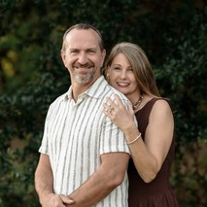
Andy & Stephanie Pace
•
Supported by Southside since 1996
The Pace family started missionary service in Peru in 1995. They have served for over 30 years, working primarily to strategically plant
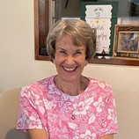
churches in unchurched areas around Lima, which has over 10 million people. The Pace family used to work in Christian education, and since moving to church planting, they have started 4 new churches. They also have a intensive ministry to help combat sex addiction called the Freedom Fight; providing education, training, and counseling to the community. They have two children: Brianna and Mikayla.

Carolyn Pace
Supported by Southside since 1968
Carolyn and her husband have been missionaries to Peru since 1968, and Southside has supported them since the beginning. She is the
mother of Andy Pace mentioned above. Unfortunately, her husband Tom recently passed. She has remained in the mission field and works at her church with Senior Adults and teaches Bible Classes at a local Activity Center for gospel outreach. Tom and Carolyn have four adult kids: Becky, Steve, Andy, and Abraham. Andy is also a missionary supported by Southside.

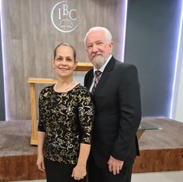
James & Hodes Nash
Supported by Southside since 1992
James and Hodes Nash are missionaries to Northeast Brazil for almost 50 years. James pastors Calvary Baptist Church. He specializes in
mentoring, discipleship, church planting, and pastoring. The Nashs are also in the process of developing a 4 year Bible Institute and intercultural studies program to help train pastors and missionaries called to serve. They host in-home Bible studies, where the go weekly into a damily or individual’s home and teach a 52 week discipleship class designed to provide a comprehensive understanding of the Bible with ultimate goal of them understanding the gospel message and accepting Jesus as Savior and Lord. He also uses countless interns to aid their ministry and be trained to become a missionary or pastor. Please pray for the success in completing the building and training for their newest projects this year. James has one adult daughter, Marca.

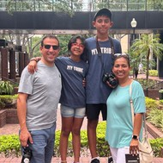
Emiliano & Vanesa Vitti
•
Supported by Southside since 2022
As of 2022, Emiliano has been the director of the Ecuador Word of Life ministry. The Vitti family has been serving there since 2020 and
previously had a ministry at Argentina Word of Life from 2002-2018. The Vitti family works in the mountains on Intensive Discipleship Center, Camps, and Local Church Ministries. Emiliano is also an IT engineer who helps develop the systems of the Word of Life Bible Institute. Vanesa is a professional business administrator who supervises their ministries and programs. They have two children: Nicolas and Abigail.

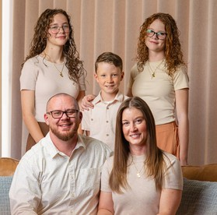
David & Katie Gardener
•
Supported by Southside since 2011
The Gardeners minister in Arequipa, Peru. Their primary ministry is rooted in church planting, pastoral training, leading a Bible College, and
pastoring Omega Church. They have been missionaries since 2005, and Southside has supported them since 2011. The Bible College they work at is successful in equipping students to plant churches and spread the gospel efficiently, sending them out with confidence in the Lord. As of February of 2026, they have graduated 297 students! The Gardeners have also begun plans for a K-12 Christian school. David and Katie have three children: Chloe, Allie, and James.

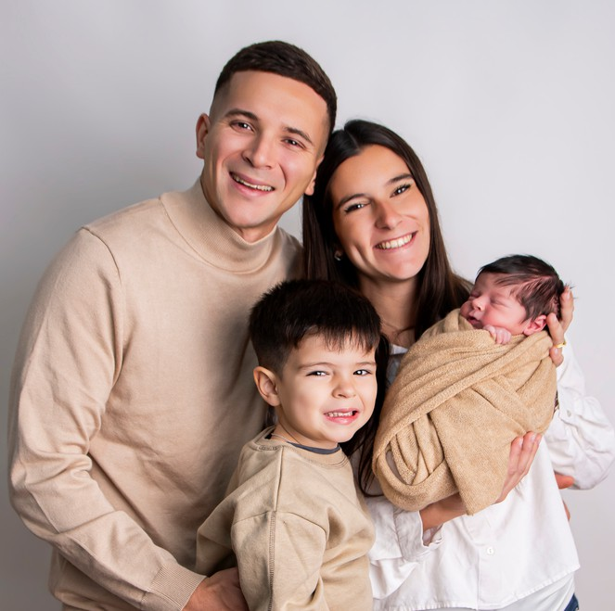
Juan & Nicole Pascua
•
Supported by Southside since 2021
Juan and Nicole are parents to two young children. The Pascua’s are dedicated servants for Christ. Juan is in charge of the Word of Life
Argentina Local Church Ministry, summer Bible camps, and his local church in Buenos Aires with the goal of making a cultural shift towards Jesus Christ. The Pascuas work for Word of Life in Argentina, and specialize in global training and evangelism of youth. Juan and Nicole have two children: Nolan and Liam.

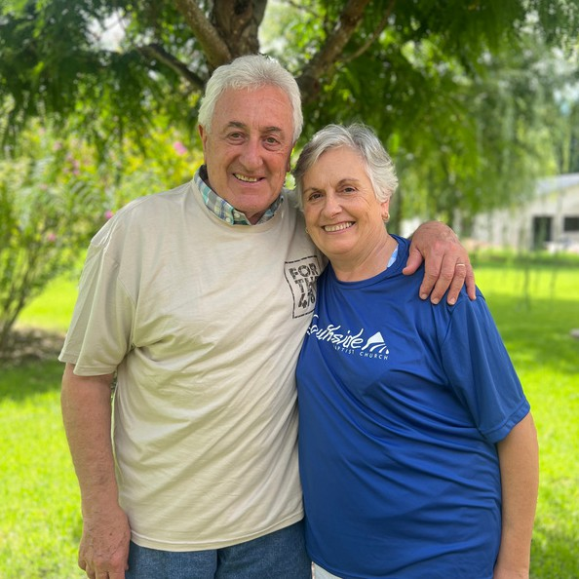
Norberto & Griselda Gimenez
•
Supported by Southside since 1995
Norberto has taught at the Word of Life Bible Institute for decades.
They are one of the founding couples that dreamed up the idea for the world renowned Bible Institute. Dedicated to teaching, pastoring, and leading the
youth, the Gimenez family are pioneers for Word of Life. They have two adult children:
Marcos and Gerardo.

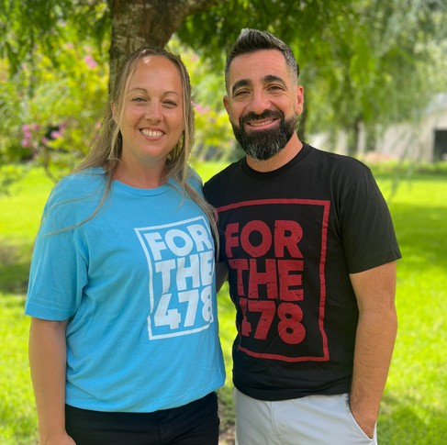
Esteban & Danielle Montllau
•
Supported by Southside since 2022
Esteban is on staff at Word of Life Argentina where he aids in the placement of graduates into different ministries. He also coaches
youth soccer teams as an outreach ministry. Danielle leads many women’s bible studies
and ministries around Word of Life Argentina. Both the 2025 Costa Rica team and the 2026 Argentina team got to spend time and fellowship with them. The Montllaus have three sons, Lucas, Damian, and Leonel.

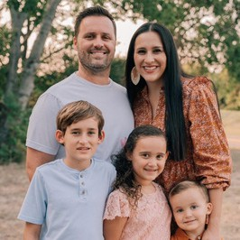
Josue & Lisa Klauser
Supported by Southside since 2011
The Klausers worked on staff at Southside Warner Robins for a year and a half while Josue was earning his doctorate degree. They then
moved to Argentina, where Josue works for Word of Life as head over the educational
instruction of the Bible Institute. Josue is the son of Guillermo and Silvia Klauser. Lisa also assists and hosts all kinds of women’s ministry events on the campus. They have three children: Benjamin, Emma, and Ian.

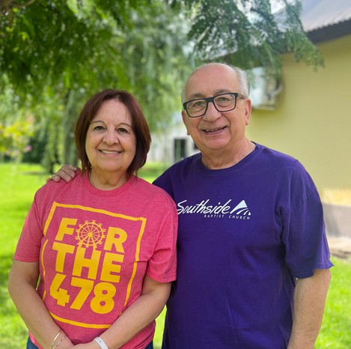
Andres & Mirta Fernandez Paz
•
Supported by Southside since 1987
Andrés is one of the previous directors of Word of Life. He and his wife are another one of the couples who began the idea for the Bible
Institute (along with the previously mentioned Gimenez family). Like Norberto, Andres goes to many conferences to teach and share the gospel. Andrés and Mirta have two adult children: Lucas and Claudia.

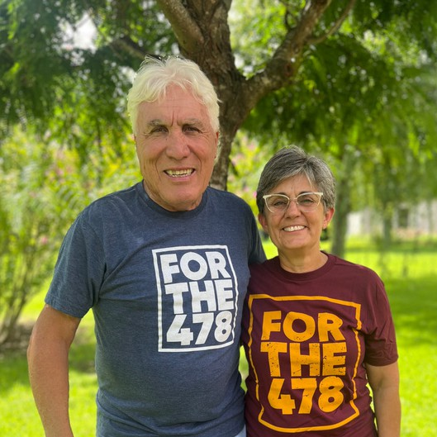
Daniel & Claudia Nogueira
•
Supported by Southside since 2014
Daniel ministers to professional fútbol teams, hosts training meetings, evangelistic rallies, youth sports events, and television and
radio. He also travels to India where he works in tandem with another WOL missionary. Claudia oversee the financial office of the Bible Institute in Argentina. They have three adult children: Ayelen, Dani Jr., and Debora.

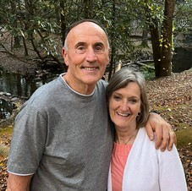
Guille & Silvia Klauser
Supported by Southside since 1998
Guille was the head of Word of Life Educational Instruction of the Bible Institute for many years. The Klausers are the parents of
Southside supported missionaries Priscila Kunzi and Josue Klauser. They are heavily involved with teaching and hosting conferences at and for the Word of Life Bible Institute in Argentina.

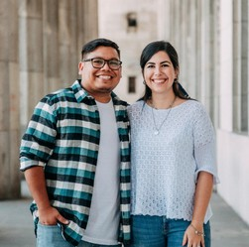
Emmanuel & Lucia Manzaneda
Supported by Southside since 2021
The Manzanedas are new Word of Life missionaries in Guyana. They are a young and devout couple that visited Southside last summer. They
are in the process of building, founding, and training for the newest Word of Life addition in the world. Guyana is the only country in South America with English as its official language! The 2025 Costa Rica team and 2026 Argentina were both able to meet with them, learning about their ministry all the while. Also, Lucia is pregnant with her first child, Eden– due in July of 2026!

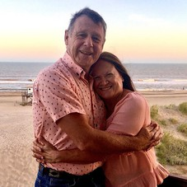
Eduardo & Gloria Buldain
Supported by Southside since 1989
The Buldains have an extreme ministry in church planting around Buenos Aires and in Coloumbia in unreached areas. Eduardo focuses
on pastoral teaching and training of believers. They work in and at their church, which is
also a missionary school. The Buldains also travel to the jungle to train pastors and provide ministry for women. Gloria has struggled with Parkinson’s disease, which has presented struggles in their traveling. However, she recently underwent double achilles surgery and has been recovering smoothly. The have two adult children who work in the ministry: Matias (Pastor), and Yanel.

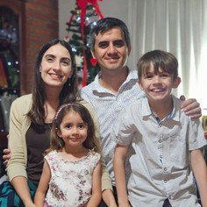
Dan & Johana Nuesch
Supported bt Southside since 2009
Dan Nuesch is the director of “The Mailbox Club” in South America.
This is an organization that prints discipleship and training material for children. This is because the Nueschs did research that showed a large majority of Christians get saved before the age of 12, but only about 20% of discipleship opportunities go to the children (not youth, but those even younger). So, all over South America they provide access to schools, churches, and training for children. Johana Nuesch, Dan’s wife, works as a major organizer for their program. The couple has two children: Ezequiel and Antonella.

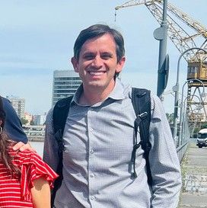
Alejandro Nuesch
•
Supported by Southside since 2009
Alejandro helps work with Franklin Graham’s ministry in preparing, training, recruiting, and setup for FGM revivals. Recently, there was a
huge outdoor event/conference in Buenos Aires for Franklin Graham to share the gospel. Over 75,000 people attended the two-day event, and Alejandro was a major helper in the discipleship and outreach follow-up of it all. Also, he is the brother of Dan Nuesch mentioned above.

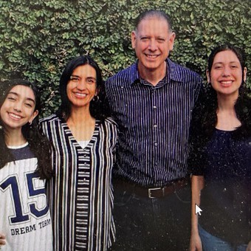
Ignacio & Monica Flandez
Supported by Southside since 2006
Ignacio is the Director of Word Of Life Uruguay. Their ministry involves Youth Outreach through Bible clubs, sports camps,
evangelism training, young adult ministry, pastor training, local church, and music productions. They also work at a Christian school part time, teaching Bible and English. Uruguay is a very secular, atheistic country, so the couple heavily prioritizes relationships for evangelism. They have two daughters: Abigail and Ivana.

Africa

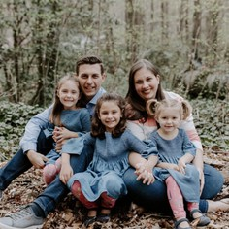
JJ & Melissa Alderman
•
Supported by Southside since 2007
JJ works for The Timothy Initiative, an organization that maps countries and plants churches. He is involved in two main projects: ACHIEVE–
initiative to place “A Church In Every Village Everywhere” and Coalition of the Willing–coordinating with 21 other organizations who partner in the mission of unreached people groups. TTI has Togo, Africa 95% mapped and plan to have a pastor planted in every location possible in four years. Since 2007, TTI had planted over 211,000 churches in unreached areas, and they believe they can double that by 2026. Along with
all of this, JJ and his group have a 2 year discipleship model program that trains pastors and missionaries to evangelize and plant churches. They have three daughters: Mia, Aubrey, and Gracen.

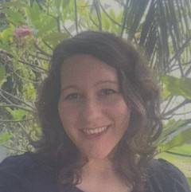
Stephanie Alderman
•
Supported by Southside since 2017
Stephanie has lived in Togo, West Africa since she was two years
old. She is a second-generation global worker, inspired by her parents' work of church planting and evangelism. Stephanie began her service overseas in 2018 as apart of the 6° initiative team. She is passionate about Next Gen, developing new leaders and believers who will reproduce bold faith in Christ. She is also JJ Alderman’s brother.

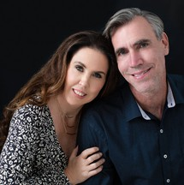
Jim & Kristina Foster
•
Supported by Southside since 1997
The Fosters serve in Cape Town, South Africa. Jim’s ministry
focuses on church planting and Christian education. Kristina’s serves as a wellness coach and has photo remembrance ministry to stillborn/terminally ill newborns. The couple has been married for 30 years! Jim has been a missionary since 1997, and Southside has supported him and his family since the start. He is the vice
principle and a teacher at their Christian school. Jim specializes in mentoring and discipling students to live and work for Christ. They also recently began a tennis table club for students to learn to compete with a gospel outreach, and it has resulted in
national champions and many great lessons for the students! Please be praying for the Foster’s ministry, as they need abundant fundraising to expand and renovate their school for more students. They have two adult daughters: Brianna and Elise.

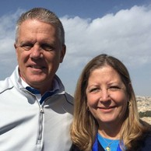
Jim & Susie Horne
•
Supported by Southside since 1989
Jim and Susie Horne have served in ministry since 1975. They were both born in the U.S., but they serve in Mombasa, Kenya. The Hornes
work with Operation Give Hope, and their abundant ministry model includes Bible Institute, church planting, Christian schools, food ministry, pastor training, and women's ministry. Every winter, Southside partners with Jim and Susie to sponsor children in Kenya through Operation Give Hope, and so many children are blessed from their efforts. They have three adult children: Jason, Rachel, and Cheryl.

Anonymous for Safety*
Supported by Southside since 2009
Missionaries to North Africa where it is 98% Muslim and illegal to proselytize for Christianity. Working through a thriving underground church, they reach people individually for Christ.

Asia

Anonymous for Safety*
Supported by Southside since 2023
Working for Word Of Life India, these missionaries focus on evangelism, sports camps, and intentional discipleship of the youth. India has become increasingly hostile to Christian evangelism and outreach recently, which makes it difficult and dangerous to evangelize.

Southeast Asia

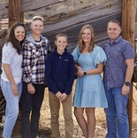
Brian & Bailey Pruett
•
Supported by Southside since 2007
The Pruett family does mission work out of the Philippines. Brian runs an helicopter flight program, where they train helicopter and
fixed winged pilots and aircraft mechanics to work in the Asia Pacific region to help make
sustainable journeys to villages. It allows inaccessible regions and people groups to gain access to the gospel for the very first time! They deliver missionaries and supplies to be able to reach these areas. The Pruetts have been serving with Ethnos360 Aviation for many years. Brian and Bailey have three children: Maycie, Dylan, and Cole.

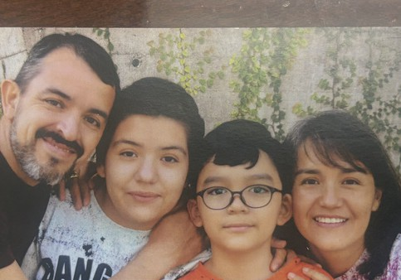
Omar & Susana Morales
•
Supported by Southside since 2026
Missionaries to Word of Life in Thailand and partnering now with Word of Life in Taiwan, the Morales’ invest in the lives of the students
through the intensive discipleship program they use. They teach, disciple, and personally counsel the students. They stay in collaboration with Thailand, working on translation materials and training programs to use in the future. The couple has two children: Zurisadai and Jahaziel.

Caribbean

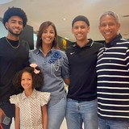
Giovanny & Carolina Valdez
•
Supported by Southside since 2010
Giovanny is the Director of Sports and Medical for SCORE in the Dominican Republic. He was personally saved through the gospel
being shared by a missions team sent by SCORE that his basketball team played as a teenager. Giovanny and Carolina’s ministry uses sports to outreach and evangelize the extensive youth of DR. They also work to support several churches in the area. They have three children: Giancarlo, Gianssen, and Gianna.

North America

Anonymous for Safety*
Supported by Southside since 2005
These missionaries started their ministry in 1999. Working as the director of Biblical Ministries Worldwide, they focus on planting churches in unreached areas, training local pastors then moving to a new plant, distributing bibles, and medical missions, etc. After
serving decades in England and Russia, they are now located in the United States.


Ed & Bonnie Gibson
•
Supported by Southside since 1990
Ed is the former BIMI Director, and the couple is retired missionaries to Japan. Serving since 1972, they are now living in Florida.
However, their work for the Lord has not ceased. Their ministry model is focused on discipleship and evangelism, where they practice individual outreach on a daily basis. They have three adult children.

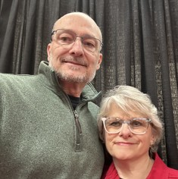
Perry & Barb Gibson
•
Suported by Douthside since 1998
Perry Gibson is the son of Ed and Bonnie mentioned above. Perry and Barb left the mission field of Japan 19 years ago. They now focus on
Japanese outreach in Seattle, Washington. The couple works with Japanese & Asian Exchange Students from nearby colleges. They host a “Talk Time” event every Thursday evening to help evangelize to students primarily from Japan, China, Indonesia, and Thailand. They also teach English as a second language to students. They have three adult children.

Anonymous for Safety*
Supported by Southside since 2006
This missionary began his ministry service during the 9/11 attack, where he prayed with victims to get saved while inside of the tower. Shortly after, he began speaking tours all over the U.S. where many people were saved. He and his wife then transitioned to focus on human/sex trafficking, where they rescue and evangelize to trafficked peoples and direct child development centers. They work all throughout the world in places like India, Ukraine, and Poland. They provide safe lodging, meals, school, counseling, and job training for people rescued from the brothels who without their ministry would have little hope.

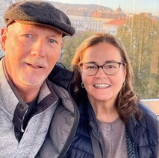
Steve & Cheryl Winget
•
Supported by Southside since 1993.
Steve and Cheryl are located in Harrisburg, Pennsylvania at the ABWE Home Office. Since November of 2021, the couple has worked
for the ABWE organization, focused on teaching, training, and children’s ministry. Cheryl is the International Missionary Kids Director, ministering and counseling children of missionaries. Steve is a part of the Resource and Development Team. Making month long trips, Steve teaches and hosts training programs to equip pastors to transform their communities. They have two adult children: Karis and Joel.

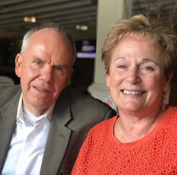
Ken & Cindy Lassiter
•
Supported by Southside since 2020
The Lassiters serve with Lassiter Coaching & Consulting Ministries. Southside began supporting the couple in 2020. Located in Georgia,
they teach, disciple, coach, and consult the church for God’s glory. Mentoring students, meeting with churches, and supporting other missionaries, the Lassiters pursue continual growth. They have three adult children.

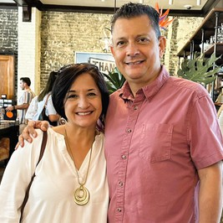
Guillermo & Mayra Aguilar
•
Supported by Southside since 1996
The Aguilars are Costa Ricans who began their missions ministry in 1992. They work with the Word of Life International Missions
Headquarters in Florida. They host and train WOL missionaries from all around the world, and they travel internationally to support and train missionaries in the field. They have two adult daughters: Andrea and Valeria.


Tim & Connie Lee
•
Supported by Southside since 1991
Tim and Connie Lee began their missionary service in 1980. They are in Texas where they specialize in evangelism. Tim Lee is a Vietnam
Veteran, who lost both of his legs during the war. Instead of living a defeated life, it propelled him into his hard-fought ministry. Directing Tim Lee Ministries, the couple goes on speaking tours all around the nation. By sharing his testimony and abundant knowledge of Scripture, Tim evangelizes to United States’ people, helping them to meet Jesus. They have three adult children: Brian, Janna, and Amber.

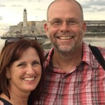
Jeff & Trudy McFarland
•
Supported by Southside since 2006
The McFarland’s ministry began in 2002. Located in Alabama, Jeff and Trudy lead TREC International (Teach, Reach, Equip, and Cover).
They work with indigenous partners in different countries such as Cuba, India, and Uganda. Training church planters, training missionaries on how to become self-sufficient, and training churches how to send short- term teams is their three main mission points as of now. They have two adult children.

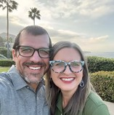
Jonathan & Michelle Walterhouse
•
Supported by Southside since 2024
Beginning in 2020, the Walterhouse family has a ministry of gospel outreach to the Deaf in the U.S. and across the world. They work with
the organization Converge in Togo to support deaf ministries in Africa. The deaf community is an unreached people group in our everyday lives, and the gospel should never be exclusive to this community. They have two sons: Jaiden and Levi.


John & Katie Zeller
Supported by Southside since 2007
Representing SCORE International, the Zellers are missionaries to the
U.S. For decades, John has spoken for SCORE as an Executive Director. Together, he and Katie share the gospel and specialize in disciple-making, specifically in a sports setting. John is currently a chaplain for the Tampa Tarpons, and he evangelizes
to many sports teams across the country. They have two adult sons.

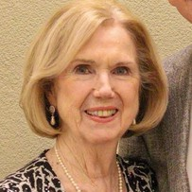
Dottie Lancaster
Supported by Southside since 1991
Southside has supported the Lancasters since the beginning of their ministry. Recently widowed Dottie lives in Tennessee. Her
and her late husband, Tom, traveled while promoting missions work. They spent decades
in Germany ministering to US service members. Now in the US, her ministry specializes in encouraging military missions at churches. They both work(ed) for BIMI European Military Missions. They have two adult sons.

Australia


Paul & Rachel Weber
•
Supported by Southside since 1999
The Weber’s mission field since 2003 has been Sydney, Australia. They just moved to plant a new church in the Melbourne area in the town of
Geelong. They began as missionaries in 1998. Working for ABWE, their primary mission is church planting, with 6 churches being founded around Sydney since 2003. Their secondary mission is teaching at university and public school as well as small groups and multiple church ministries. They have five children: Andrew, Jonathan, Benjamin, Anna, and Sarah.

Central America

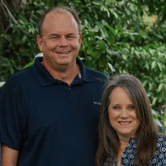
Bruce & Laura Edgar
•
Supported by Southside since 2003
The Edgars first began their ministry in missions in 2003, and have served for many years in Nicaragua. Bruce and Laura have recently transitioned into
the role of Executive Directors’s within ABWE’s missionary leadership structure, which is the highest level of leadership within that framework. They serve the Latin America and Caribbean regions. The Edgars’ primary mission is training church planters who will evangelize boldly and disciple wisely. They have two adult children: Peter and Emma.

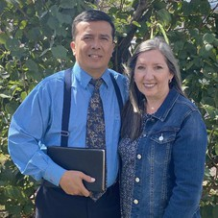
Aby & Gladys Prado
•
Supported by Southside since 1990
Aby and Gladys went through Word of Life Argentina, and started as missionaries from Southside Baptist on 9/13/1990. They are currently
working under Southside’s Mission Point Ministry. The Prados work to train pastors,
plant churches, and pastor churches in San Jose and Limon, Costa Rica. Aby has trained 1,840 ministers and has planted 135 churched throughout the world. They have two adult children.

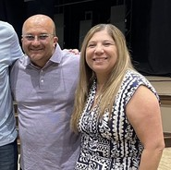
Jose & Gaby Prado
•
Supported by Southside since 1992
Jose and Gaby minister through Hope Baptist Church in San Jose, Costa Rica. As the brother of Aby mentioned above, they do very similar
missions work. Jose and Gaby minister with food, education, sports, church, and travel. Their church establishes all kinds of outreach to the lost. They feed the homeless, provide materials for students, housing for mothers, and so much more. They have three adult daughters: Melany, Melissa, and Michelle.

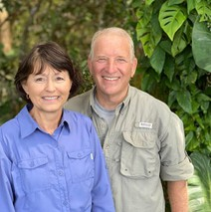
Russ & Lynn Turner
•
Supported by Southside since 1983
The Turners are missionaries to Latin America. They travel to indigenous tribes in the jungle, spreading the gospel to unreached areas. Not only that,
but they travel to these unreached areas to do pastoral training to send out indigenous missionaries to go even further. It is incredibly dangerous and risky, but that has never stopped the couple. They have been dedicated to missions since 1978. They have three adult children: Lathon, Richard, and Rachec.

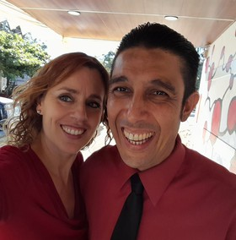
Steve & Christine Cerna
•
Supported by Southside since 2004
Beginning their missionary work in 2003, the Cerna family is faithful to the church in El Salvador. With a focus on church planting and local
ministry, Steve and Christine operate multiple ministries from their church. They focus on evangelism, pastor training, church planting, English education, and discipleship. They have three chidlren: Rosa, Caleb, and Joshua.

